|  |
| --- |
| **Experimentation (part 1)** |
| Follow the following steps and tasks. In some of them, you will be asked to save your time |
| The collaborative configuration during this experiment consists of a group that configures the product and a product manager who checks the configuration and runs the conflict resolution process.  *If you are reading this, you are the product manager☺* |

* **Task 1 (Conflict resolution)**

**Current time (put the time when you are ready to start this task):** HH: MM

1. Login with the login and password "admin, admin" and click on "Login".

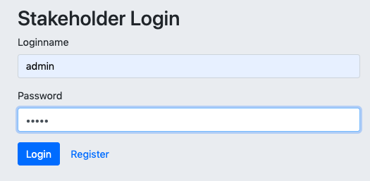

1. In the window that appears (as shown in the figure below), click on the "Merge" button to merge the participants' configuration choices.

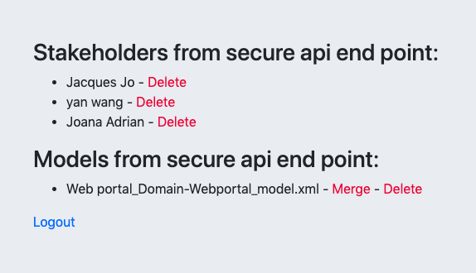

1. In the overview window that appears, select a priority participant. Respecting the configuration choices of the participant you are about to select will be one of the criteria to consider in the conflict resolution process.

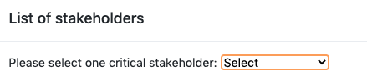

1. Check the option « send the final configuration to all the stakeholders »



1. Click on « Start resolution »
2. The list of possible corrections (combination of choices to be deleted) will be displayed, click on "Ok".
3. The combination that goes with the rules chosen by the participants will be displayed, click "Ok".

The corrected final configuration is displayed.

1. Log out.

**Final time (record your current time after finishing this task):** HH: MM